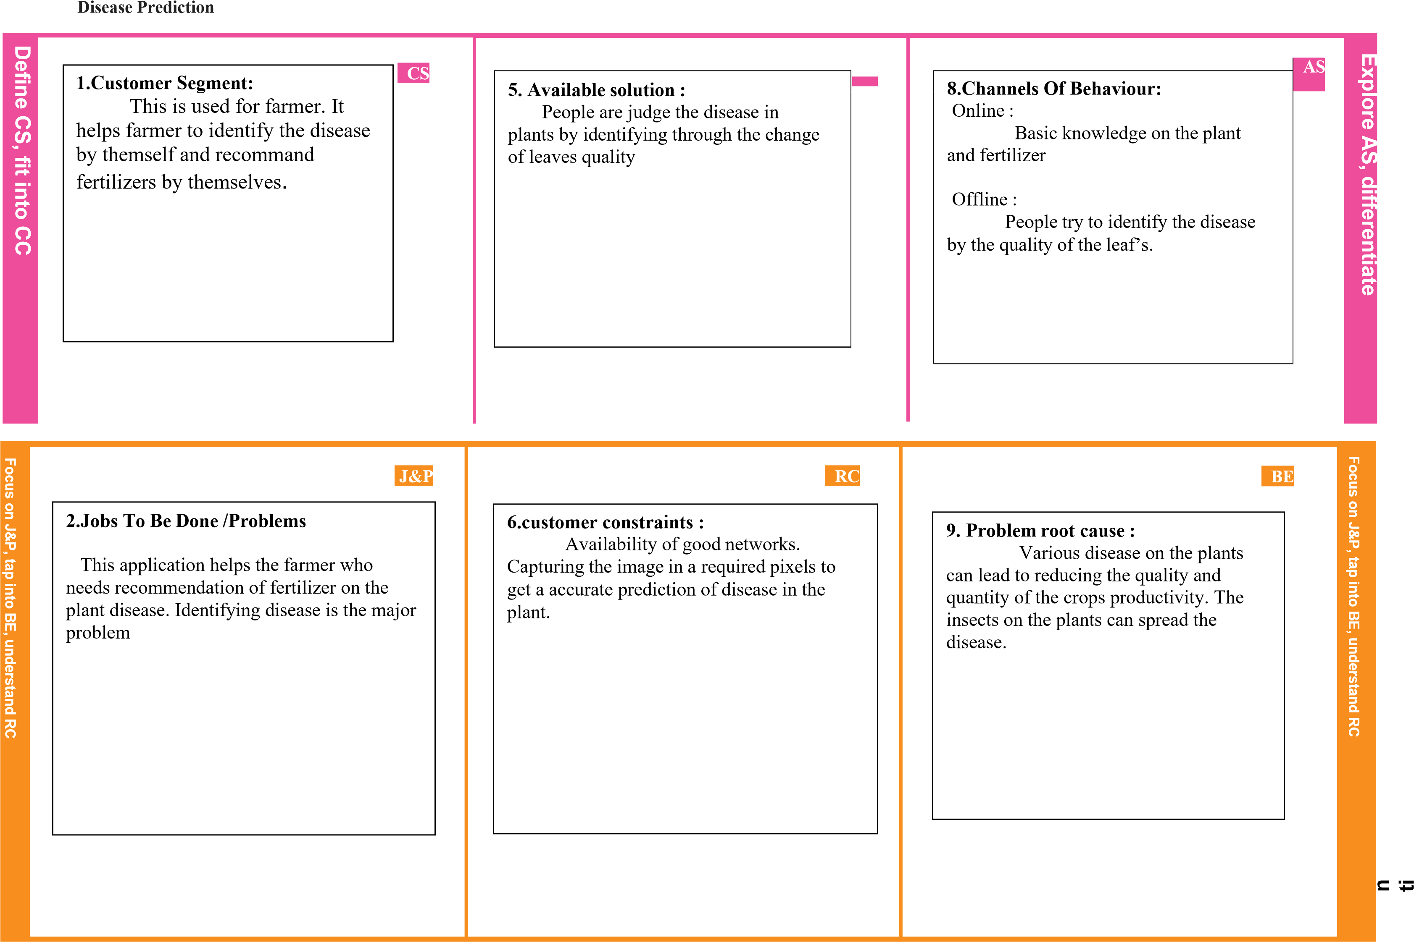Project Title: Fertilizer Recommendation System For Project Design Phase-I - Solution Fit Team ID: PNT2022TMID36289

|  |  |  |  |  |  |  |  |  |  |
| --- | --- | --- | --- | --- | --- | --- | --- | --- | --- |
|  | TR  3.Triggers :  Seeing their crops are  being infected by disease and facing huge loss in quantity and quality |  | SL | |  | CH | | |  |
|  | 7.Behaviour :  Directly :  Farmer can easily identify the  disease by the application and they don’t need any extra knowledge on the disease prediction    Indirectly :  Farmer can be able to get result  through online immediately. |  | 10. Solution :  Using the fertilizer is one the solution for the disease in the plants. Our Application use the image of the infected plant by identifying the disease and suggest the good fertilizer for the disease |  |
| EM   |  | | --- | | 4.Emotion :  Before : losing self-confidence ,distress  After : gaining self-confidence ,relief | |  |